PRACTICAL 3

Name : Ranudi Gayathmie Kariyapperuma
Index : 29897
Batch No : 23.1
Degree Program Name : Technology Management

#include<stdio.h>
int main()
{
int n1,n2,max;
printf("Enter two numbers: \n");
scanf("%d%d",&n1,&n2);

if(n1>n2)
max = n1;
else
max = n2;

printf("The Highest number is %d \n",max);
return 0;
}

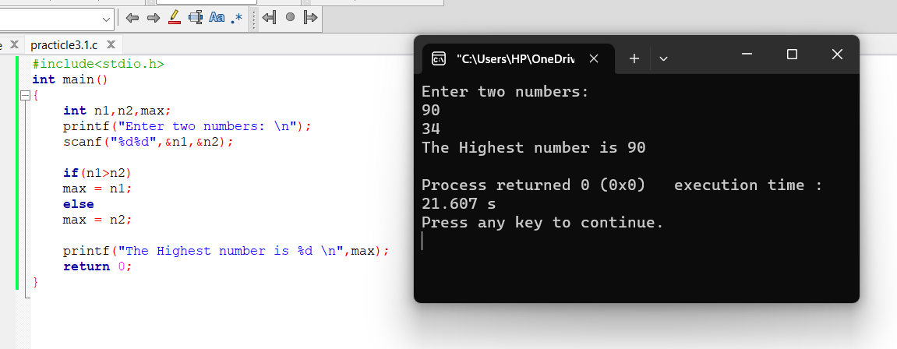

#include <stdio.h>
int main()
{
int n1,n2,n3,largeno,smallno;
printf("Enter three numbers: ");
scanf("%d%d%d",&n1,&n2,&n3);

largeno = n1;
smallno = n1;

if (largeno<n2)
largeno = n2;
if (largeno<n3)
largeno=n3;

if(smallno>n2)
smallno=n2;
if (smallno>n3)
smallno=n3;

printf("The Largest number is %d and the smallest number is
%d \n",largeno,smallno);

return 0;
}

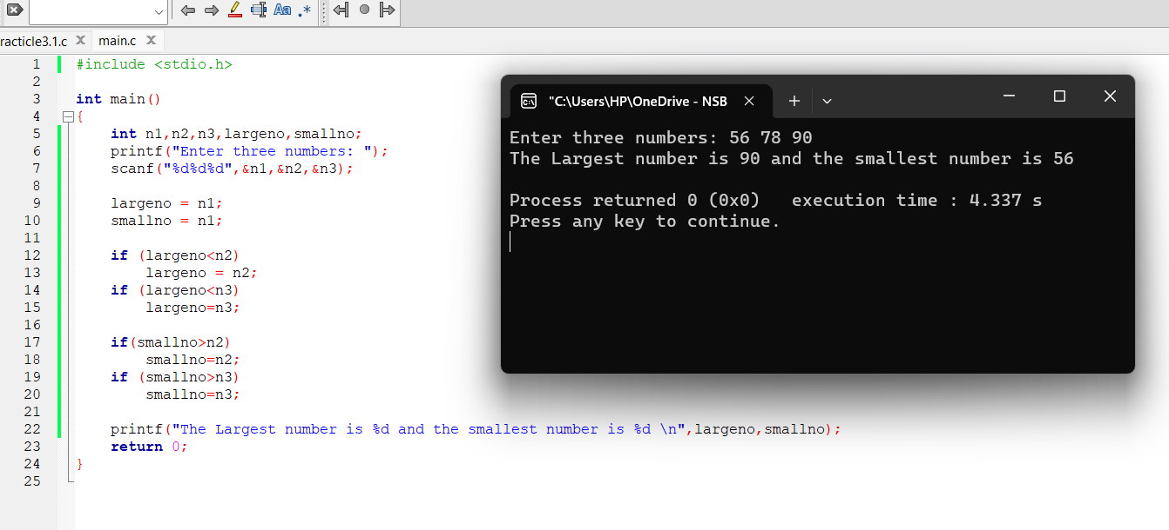

#include <stdio.h>
int main()
{
char emname[25];
float basicsalary,newsalary,incre;

printf("Enter Employee name:");
scanf("%s",&emname);

printf("Enter Basic Salary:");
scanf("%f",&basicsalary);

if(basicsalary>=10000)
incre=basicsalary*0.15;

else if(basicsalary>=5000)
incre=basicsalary*0.10;

else
incre=basicsalary*incre;

newsalary = basicsalary+incre;

printf("Employee name is %s and the New salary is
%.2f\n",emname,newsalary);
return 0;
}

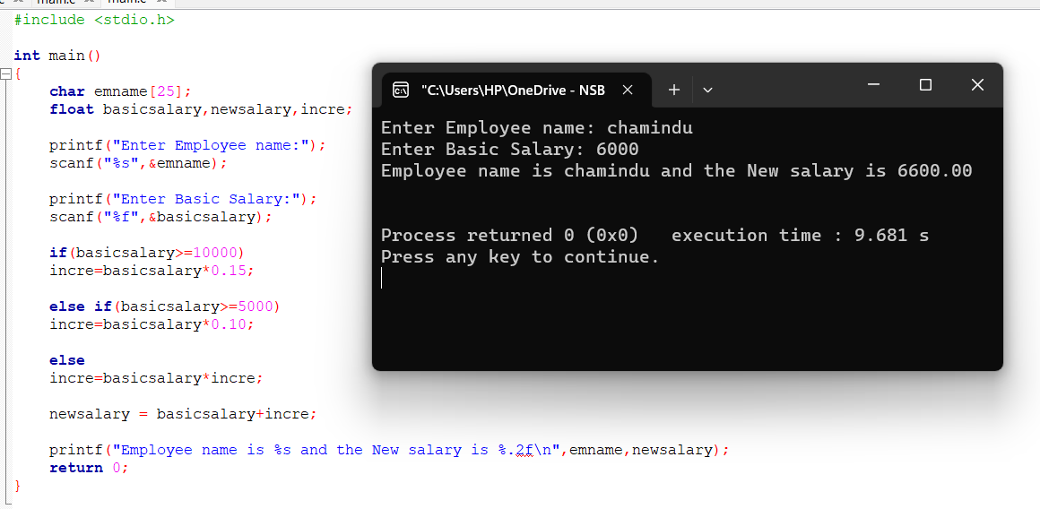

#include <stdio.h>
int main()
{
float radius,diameter,circumference,area;

printf("Enter the radius of a circle: ");
scanf("%f",&radius);

diameter=2*radius;
circumference=2*3.14159*radius;
area=3.14159*radius*radius;

printf("The diameter of circle is %f\n",diameter);
printf("The circumference of circle is %f \n",circumference);
printf("The area of a circle is %f \n",area);

return 0;
}

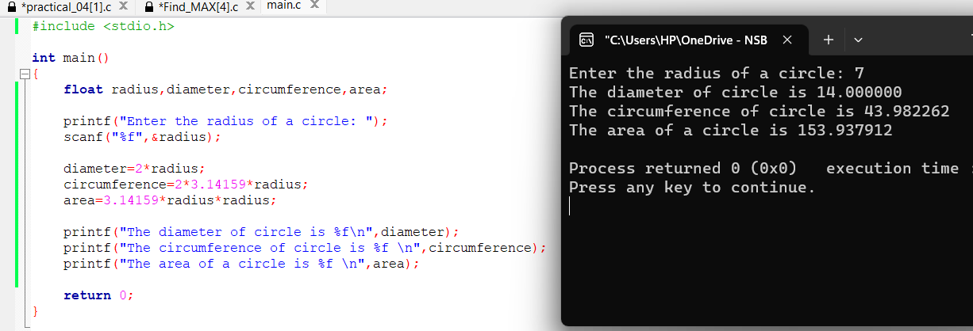

- #include <stdio.h>

int main()
{
int n1,n2,n;

printf("Enter two numbers:\n ");
scanf("%d%d",&n1,&n2);

n =n1%n2;

if(n==0)
printf("%d is a multiple of %d ",n1,n2);
else
printf("%d is not a multiply of %d",n1,n2);

return 0;
}

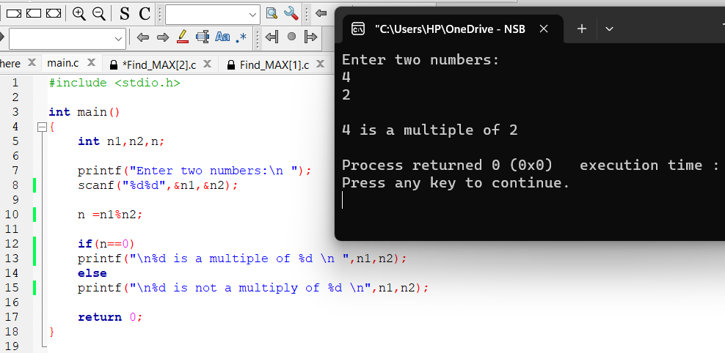

- #include <stdio.h>
int main()
{
char ch;
printf("Enter a character among these: A,B,C,a,b,c,0,1,2,$,*,+,/ \n ");
scanf("%c",&ch);

if ('A'==ch)
printf("The integer value of A is %d\n",'A');
else if('B'==ch)
printf("The integer value of B is %d\n",'B');
else if('C'==ch)
printf("The integer value of C is %d\n",'C');
else if('a'==ch)
printf("The integer value of a is %d\n",'a');
else if('b'==ch)
printf("The integer value of b is %d\n",'b');
else if('c'==ch)
printf("The integer value of c is %d\n",'c');
else if('0'==ch)
printf("The integer value of 0 is %d\n",'0');
else if('1'==ch)
printf("The integer value of 1 is %d\n",'1');
else if('2'==ch)
printf("The integer value of 2 is %d\n",'2');
else if('$'==ch)
printf("The integer value of $ is %d\n",'$');
else if('*'==ch)
printf("The integer value of * is %d\n",'*');
else if('+'==ch)
printf("The integer value of + is %d\n",'+');
else if('/'==ch)
printf("The integer value of / is %d\n",'/');

return 0;
}

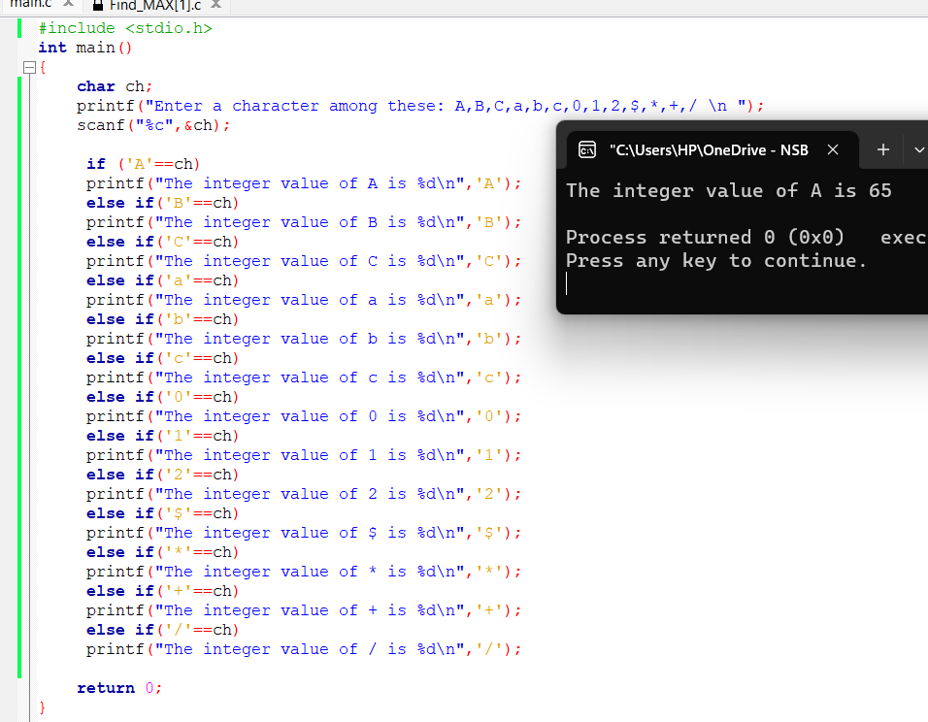

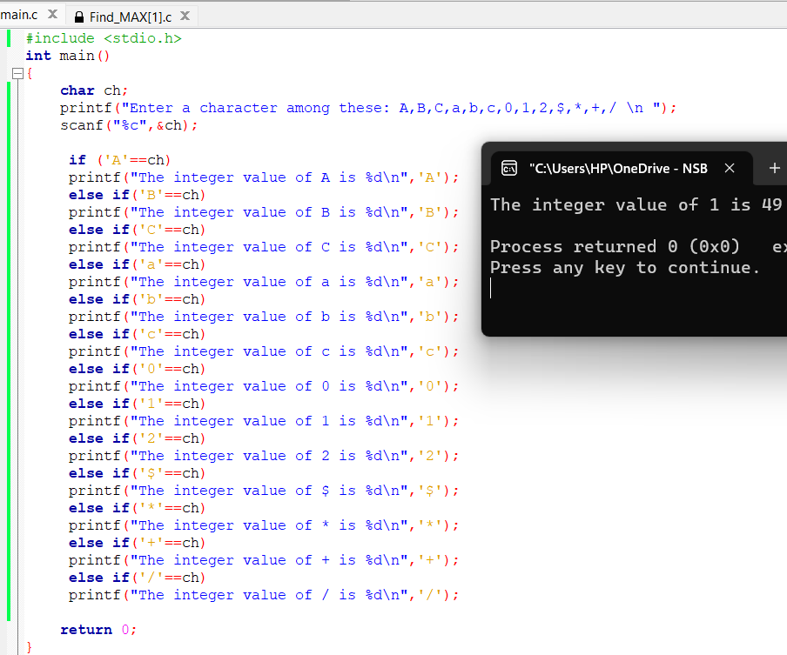

int main()
{
Float basicsalary,additionalallowance,bonus,monthlysales
,grossremuneration;
int noofyears;
char city;

printf("Enter basic salary: ");
scanf("%f",&basicsalary);

printf("Enter the no of service: ");
scanf("%d",&noofyears);

printf("Enter the city ('c'= Colombo, 'O'= other): ");
scanf(" %c", &city);

printf("Enter the monthly sales: ");
scanf("%f",&monthlysales);

if(noofyears>5)
additionalallowance+=0.1*basicsalary;
if(city=='c')
additionalallowance+=2500;

monthlysales=0;
if(monthlysales>=50000)
bonus=monthlysales*0.15;
else if(monthlysales>=25000)
bonus=monthlysales*0.12;
else
bonus=monthlysales*0.10;

grossremuneration= basicsalary+additionalallowance+bonus;

printf("Gross Monthly Remuneration:
%2f",grossremuneration);

return 0;
}

